**[2CEIT503: COMPUTER NETWORK]**

Practical: 3



**AIM: Studying Windows network commands.**

**ping, pathping, ipconfig/ifconfig, arp, netstat, nbtstat, nslookup, route, traceroute/tracert, nmap**.



**Department of Computer Engineering/Information Technology**

**Ipconfig :**

The ipconfig command is a fast way of determining your computer’s IP address and other information, such as the address of its default gateway useful if you want to know the IP address of your router’s web interface.

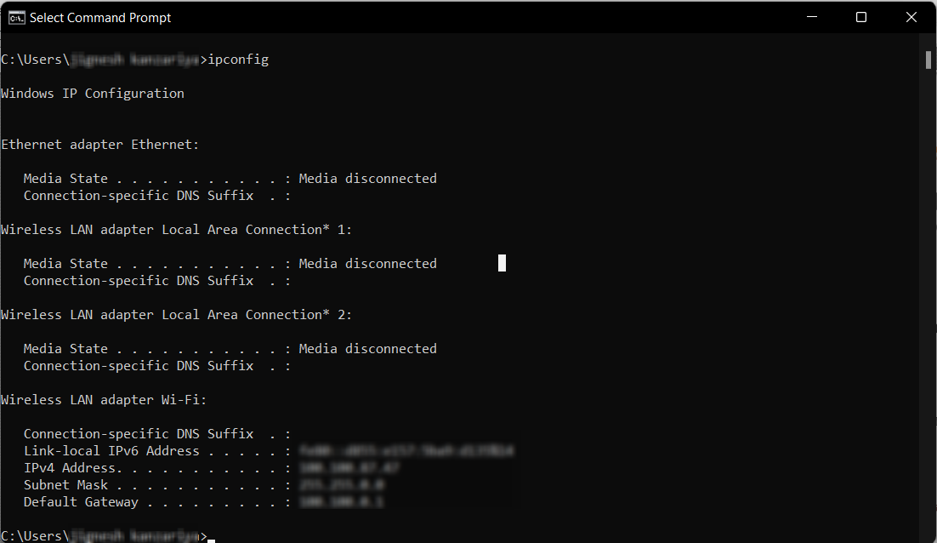

**Ipconfig/all :** all information about system.

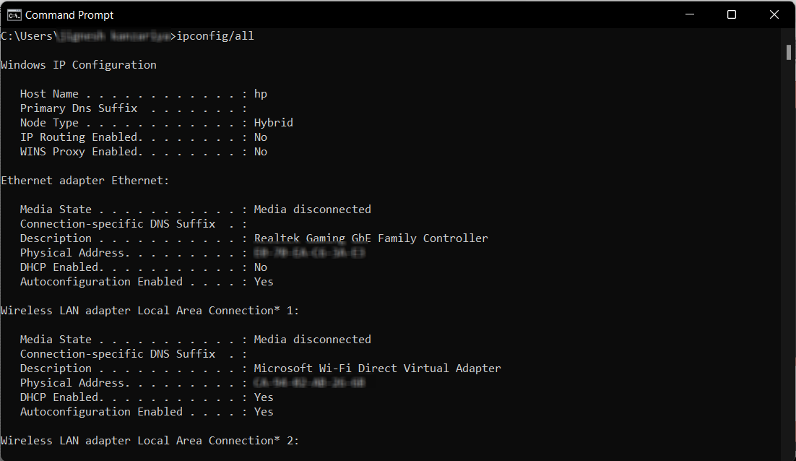

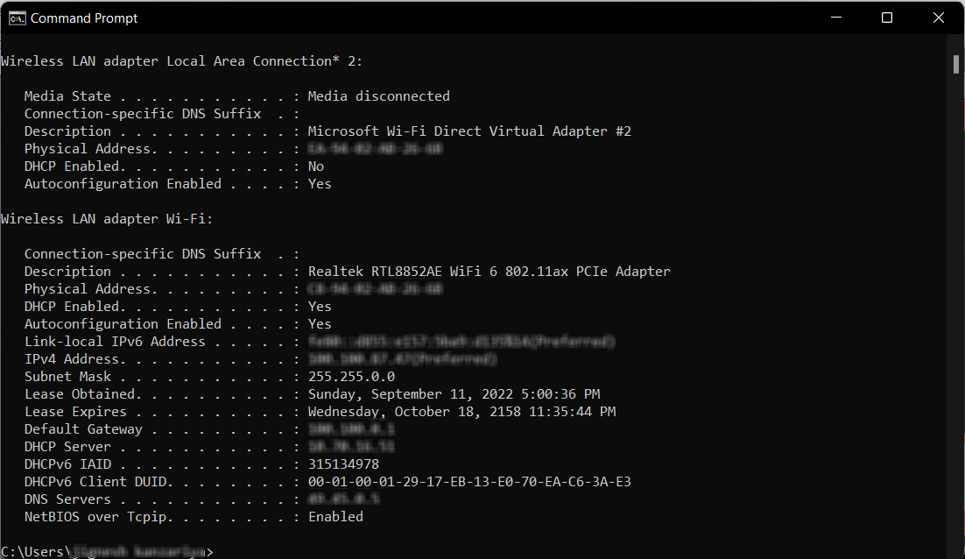

**Ping :**

Ping is an old Unix tool that has been around for a long time but many PC users are unfamiliar with the Windows version. Ping sends out a packet to a designated internet host or network computer and measures its response time. Use ping whenever you need to verify that a host computer can connect to the TCP/IP network and network resources.

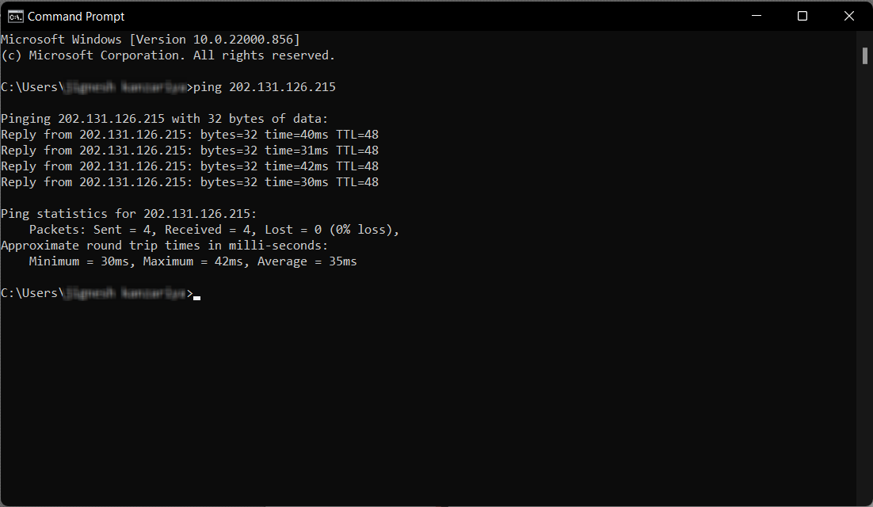

**Arp –a:** Displays and modifies the IP-to-Physical address translation tables used by address

resolution protocol (ARP).

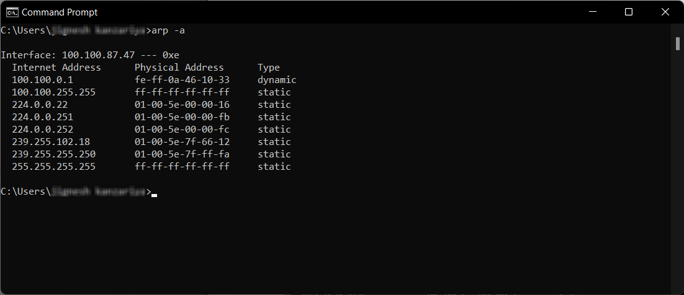

**Netstat :**

Netstat stands for network statistics. This command displays incoming and outgoing

network connections as well as other network information. The netstat utility can show you the

open connections on your computer, which programs are making which connections, how much

data is being transmitted, and other information. The netstat command is a used to display very

detailed information about how your computer is communicating with other computers or

network devices.

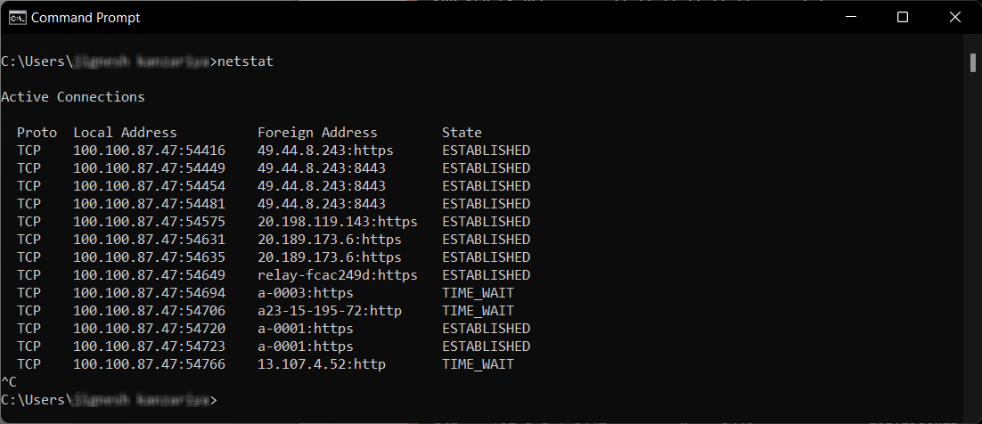

**netstat –n:**

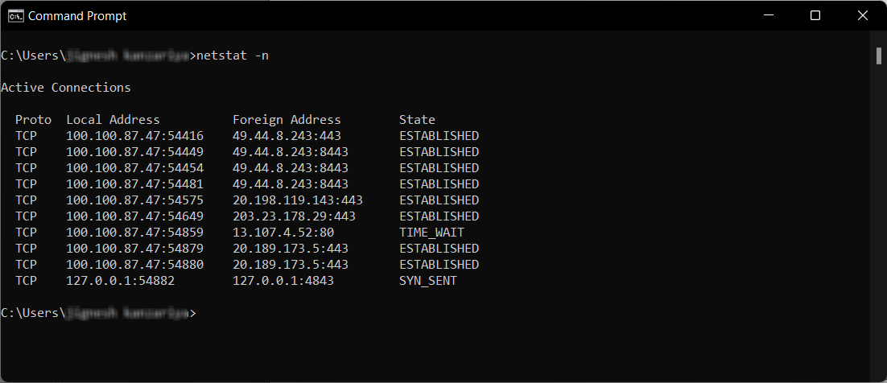

**Nslookup:** nslookup, which stands for "name server lookup", is a useful tool for finding out

information about a domain named . This command helps diagnose the Domain Name System

(DNS) infrastructure and comes with a number of sub-commands. These are mainly for systems

administrators. The primary interest for average PC users is its use to find the computer name

corresponding to a numeric IP.

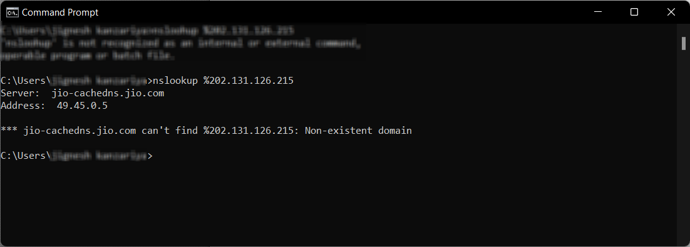

**Tracert :** A tracert is a tracking of a packet sent to a server. During its route this packet goes

through several network devices (routers, firewall, etc.) and then goes finally at the server. With

the tracert you can see the IP as well as the response time between each barrier.

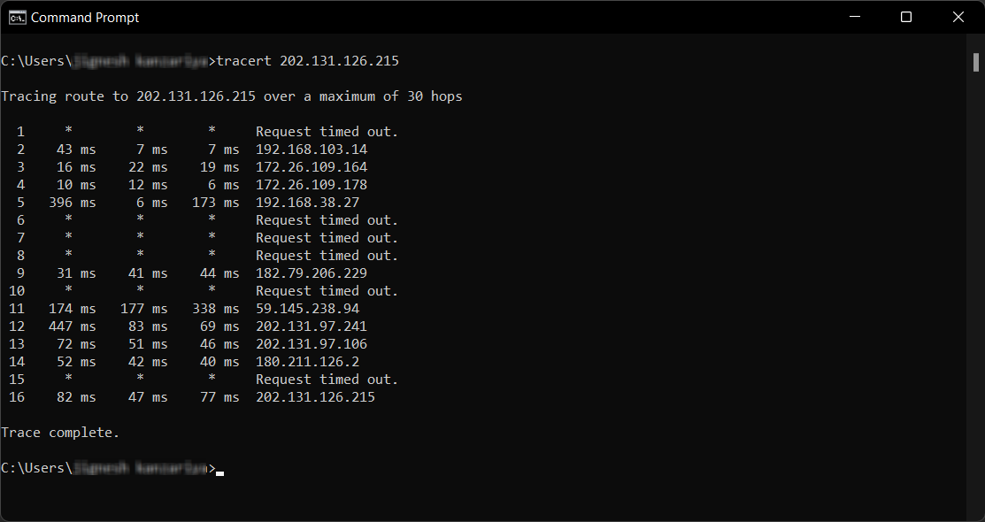

**Route:** If this is used in conjunction with one of the commands (such as add, change, or

delete), the table is cleared prior to running the command. -p : When used with the add

command, the specified route is added to the registry and is used to initialize the IP routing table

whenever the TCP/IP protocol is started.

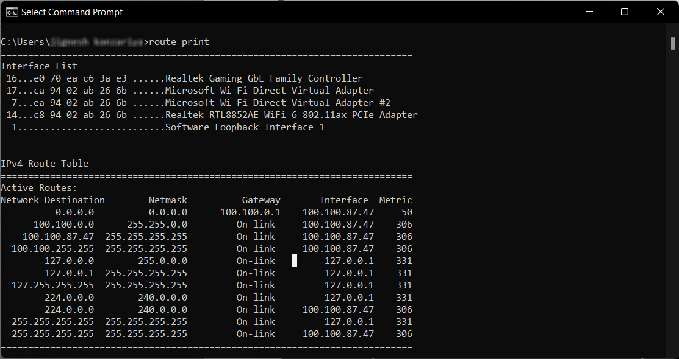

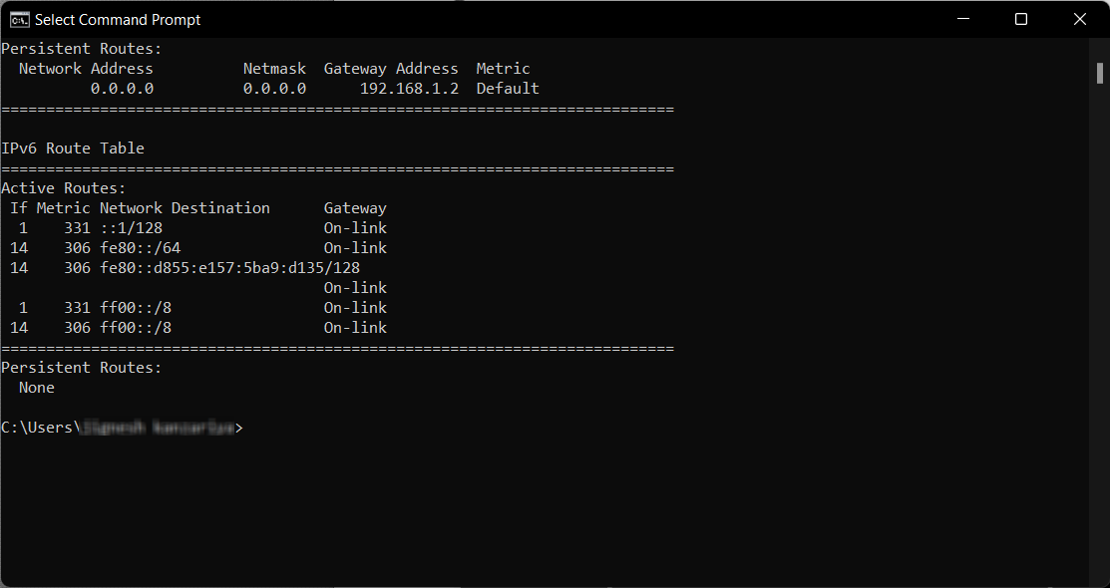

**Ipconfig –flushdns :** To ensure Windows is getting addresses from the new DNS servers instead of using

old, cached entries, run the ipconfig /flushdns command after changing your DNS server.

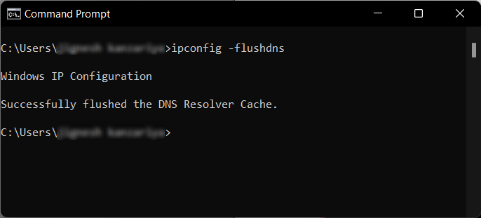

**Hostname:** Useful to know machine name.

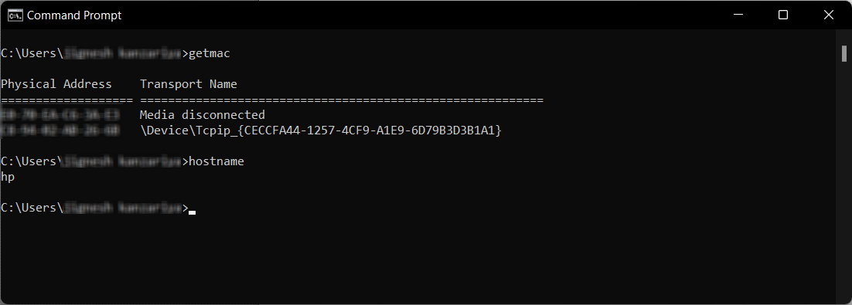

**Pathping:** The pathping command is a route tracing tool that combines features of

the ping and tracert commands with additional information that neither of those tools provides.

The pathping command sends packets to each router on the way to a final destination over a

period of time, and then computes results based on the packets returned from each hop. Since the

command shows the degree of packet loss at any given router or link, it is easy to determine

which routers or links might be causing network problems.

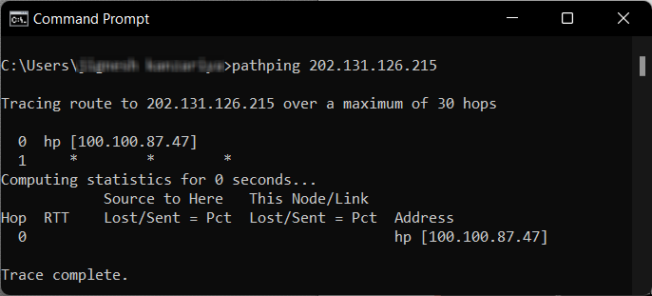

**getmac:** using this command we can get MAC address.

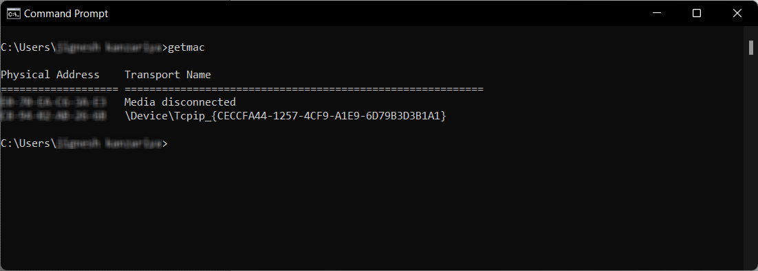

**Nbtstat :** Displays protocol statistics and current TCP/IP connections using NBT(NetBIOS over TCP/IP). Lists the remote machine's name table given its name.

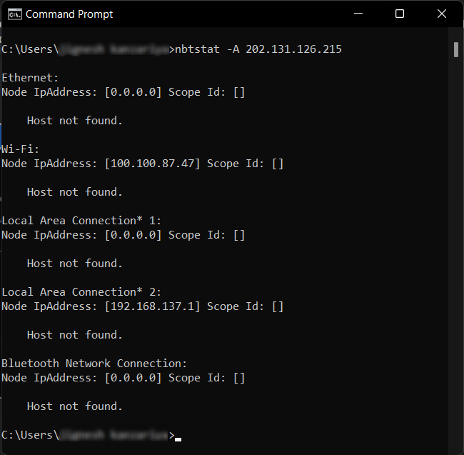

**telnet :** The telnet command to access to a remote host in Terminal mode (passive screen) .

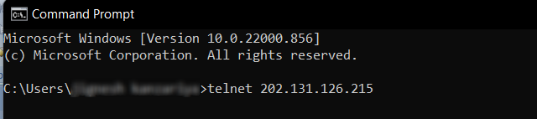

**net view:** There may be a time where you want to see what devices are connected to your network. This is where the net view command comes in.

